[International Certificate in Occupational Safety & Health](http://www.asheinstitute.com)  
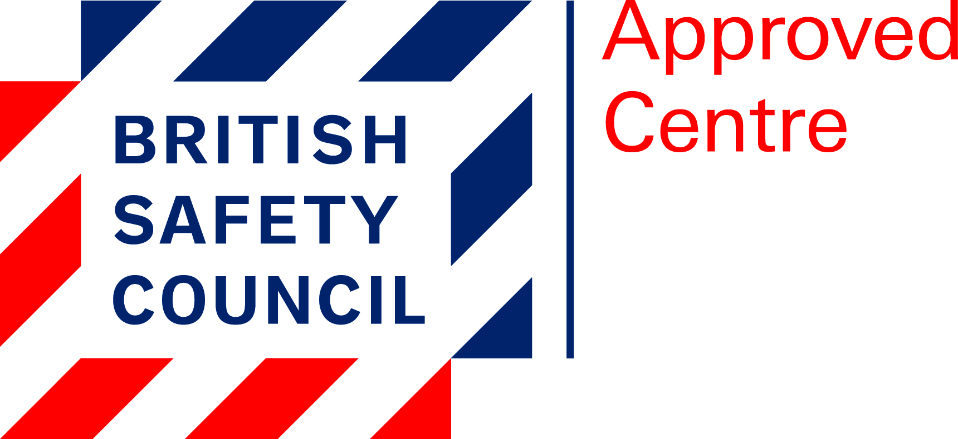  
For more than 60 years British Safety Council have been a trusted leader in health, safety and environmental management. They have educated millions of workers and made hundreds of thousands of workplaces healthier and safer for everyone. British Safety Council do this by sharing information, supporting organisations as they change, advising, educating and campaigning for effective legislation.  
Health and safety is a complex area. In any workplace there are multiple hazards that can harm workers, the broader environment or both, requiring different levels of risk management. They help you to reduce risks sensibly, making workplaces healthier and safer for everyone and improving long-term business performance.  
British Safety Council have changed the world of work for the better and we’ll never stop, because excellent health, safety and environmental management is good for your people and good for your business.  
The International Certificate focuses on embedding health and safety into an organisation’s culture and highlights the key role of communication in securing senior management commitment.

**This Course is Suitable For?**Health and safety professionals who are wanting to advance their professional career or undertake further HSE study.

**Is This Qualification Recognised?**This qualification is also accepted by the International Institute of Risk and Safety Management (www.iirsm.org) as meeting their requirements for full membership (MIIRSM). United Kingdom professional health and safety bodies have a growing international reputation with a number of international branches being formed.  
Meets the academic requirement for Technical membership of IOSH (Tech IOSH).

**Benefits of the Course.**On successful completion of the qualification, the Certificate holder may apply for Technical member (Tech IOSH) of the Institution of Occupational Safety and Health (IOSH), the major UK professional body in the field (www.iosh.co.uk).Holders of the British Safety Council International Diploma in Occupational Health and Safety may use the designatory letters “ICertOSH” after their name.  
The British Safety Council International Certificate is a prestigious and demanding professional qualification for those wanting to advance their career in occupational health and safety.  
ICertOSH is recognised around the world as the global standard for health and safety professionals. It aims to provide the knowledge and understanding that strengthen performance of a Health and Safety Professional.

**Entry Requirement**There are no specific entry requirements for this qualification. Fresher’s – Core Engineering graduates, Science graduates & polytechnic diploma holders. Good standard of written English communication is required since the examinations are held in English.

**Course Content**The International Diploma is divided into Three units, each of which is assessed separately:  
The health and safety responsibilities of employers and employees.

* The influence of international agencies and standards.
* Organising health and safety in the workplace.
* Developing a positive health and safety culture.
* Preventing accidents in the workplace.
* The importance of effective occupational health provision.
* Health and safety management systems.
* Risk assessment and risk management.
* The hazards and risks associated with workplace activities.
* Controlling risks in the workplace.
* Fire prevention in the workplace.
* Managing emergencies in the workplace.
* Reporting and investigating incidents in the workplace.
* Reducing the impact of workplace activities on the environment.

**Exam**The International Certificate in Occupational Safety & Health exam is assessed in Two units: All the Candidate scripts are marked by external examiners appointed by British Safety Council.

**Certification**Successfully completing the International Certificate in Occupational Safety and Health leads to Technical Membership of IOSH. Results and certificates issued within 30 working days.